**TEST SCENARIOS**

**Scenario 1: Initial Rendering**

**Description:** The timer componente should render with initial settings properly.

**Test Steps:**

1. Render the Timer.js component
2. Find the “Start” , “Stop” and “Reset” buttons.
3. Find the start time display which is set to "25:00".

**Expected Outcome:** Timer.js component should be rendered with all buttons and the start time displayed as "25:00".

**Scenario 2: Starting the Timer**

**Description:** The Timer component should start counting down when the "Start" button is clicked.

**Test Steps:**

1. Render the Timer.js component
2. Click the "Start" button.
3. Test the elapsed time by counting down the timer by 1 second.
4. Check for the updated time display.

**Expected Outcome:** The timer should start counting down, and the time display should update.

**Scenario 3: Stopping the Timer**

**Description:** The Timer component should pause counting down when the "Stop" button is clicked.

**Test Steps:**

1. Render the Timer.js component
2. Click the "Start" button.
3. Counting down the timer by 1 second.
4. Click the "Stop" button.
5. Check for the time display to remain unchanged.

**Expected Outcome:** The timer should pause, and the time display should not change after clicking the "Stop" button.

**Scenario 4: Resetting the Timer**

**Description:** The Timer component should reset to the initial time when the "Reset" button is clicked.

**Test Steps:**

1. Render the Timer.js component
2. Click the "Start" button.
3. Counting down the timer by 1 second.
4. Click the "Reset" button.
5. Check for the time display to show "25:00".

**Expected Outcome:** The timer should reset to the initial time of "25:00" when the "Reset" button is clicked.

**MANUAL TESTS:**

* After almost 10 minutes, it is still working properly:  
    
  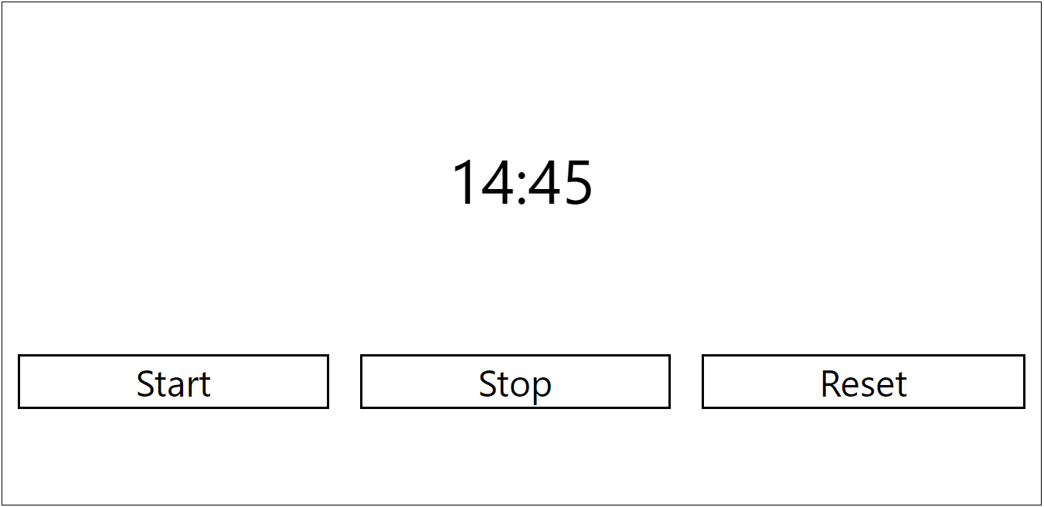
* After almost 15 minutes, it is still working properly:

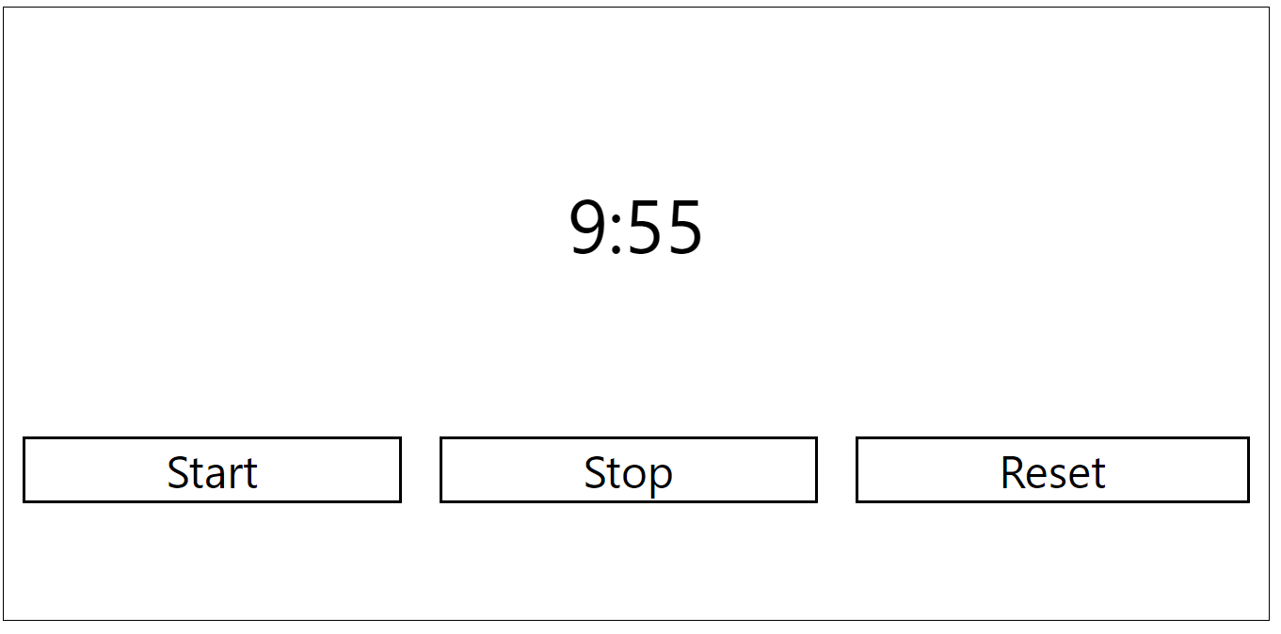

* After almost 20 minutes, it is still working properly:

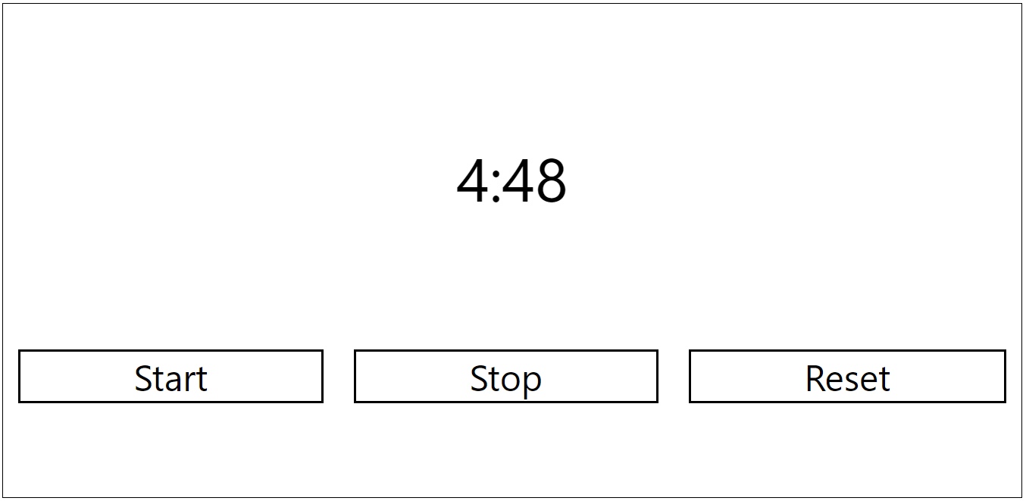

* After 25 minutes, it stays as in the screenshot below 00:00, it does not go down to negative values and nothing changes when the start stop button is clicked, so it works properly. Reset also works correctly after the application reaches 00:00.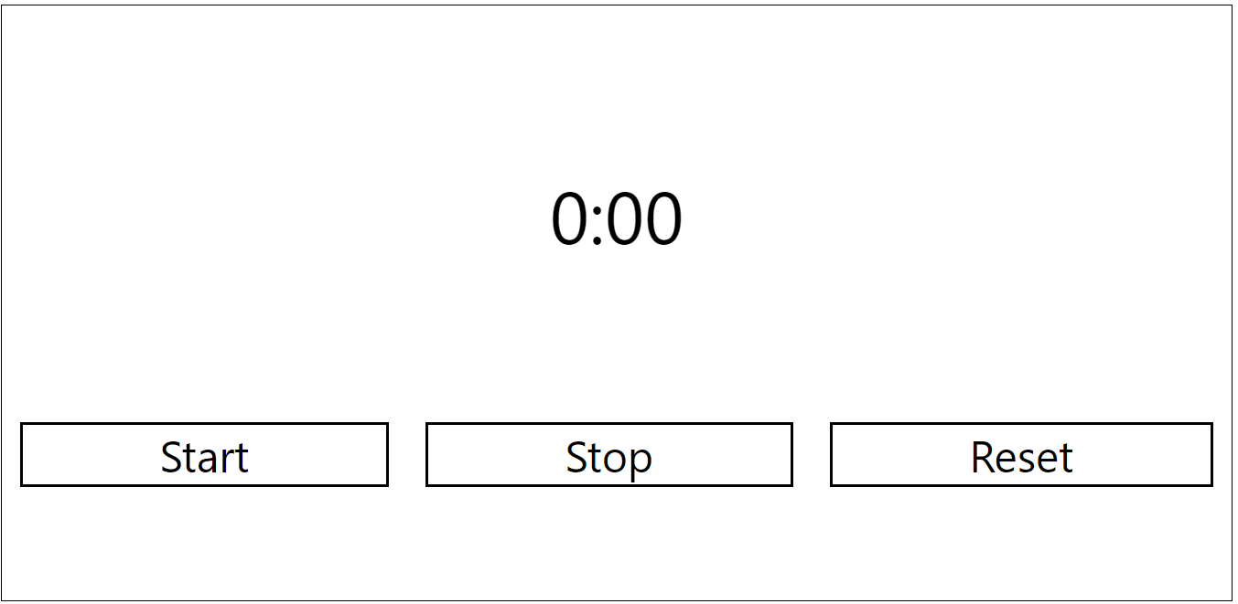
* Start, Stop and Reset buttons have been checked while app was running. After app was started start button had been clicked multiple times and display had not been broken. The same process had been applied to stop and reset button and display had not been broken , the application worked properly.
* The Start & Stop buttons have been checked every single minutes while the timer was counting down. So far so good, whole functionality has been working properly. Reset button has also been checked in the middle of the counting down process and it has worked as expected.